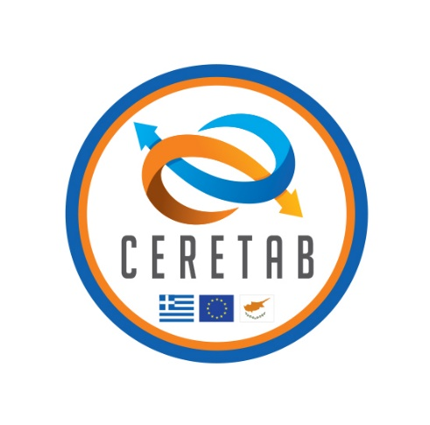

**Project: CERETAB**

**Project Duration: 1/12/2018 - 30/11/2021 (36 months)**

**Overall Budget: €1.023.990,00**

|  |
| --- |
| CERETAB aims to support the improvement of border surveillance by enhancing cooperation between 2 EU Member States, Greece (EL) & Cyprus (CY), which over the recent years suffer from heavy irregular migration attempts via the Mediterranean Sea, as well as cross-border crime.  The unique geographical position of both countries in the South Eastern end of the EU renders them as significant targets for smuggling groups, using small maritime vessels. The overall objective is to increase the situational awareness within the broad area defined by the Greek-Cypriot sea borders, by the improvement of the cooperation and the information exchange of the Greek-Cypriot National Coordination Centers (NCCs). More specifically, the area between Cyprus and Greece is considered a sea route for suspected vessels moving from Turkey, Syria & Lebanon towards Europe and it is widely acknowledged that it lacks proper monitoring. Thus, timely effective and secure exchange of information & coordination between the relevant authorities of the 2 countries is of utmost importance.  The latter will be implemented within CERETAB project through the utilization of new, state-of-the-art border surveillance technologies, such as the deployment of Unmanned Aircraft Systems (UASs), that facilitate information exchange, in order to prevent cross border crime & irregular migration, while optimizing the common efforts for saving lives of people in distress at sea, e.g., in Search and Rescue (SAR) incidents.  In line with Article 9(9) & (10) of Reg. (EU) No 1052/2013 on the exchange of situational pictures of neighboring border sections, CERETAB will provide an integrated ICT platform that will enable both neighboring countries to exchange and share directly & in near real-time incident-related information, such as the 2 NCCs situational picture, in order to promote a more coherent approach on migration management (including SAR incidents), and to fight irregular migration and cross-border crime. |

**Context of the Action**

|  |  |  |  |
| --- | --- | --- | --- |
| The CERETAB project tackles significant irregular migration and communication awareness and information exchange activities occurring within the South Eastern Mediterranean area formed by the sea borders of two Member States. It clearly meets 2 priorities set by the Call for proposals regarding direct and near-real time exchange of information gathered from the situational pictures of neighboring external border sections leading to increased situational awareness, and the purchase and technical upgrade of related surveillance equipment that will acquire real-time picture of suspect vessels. It will facilitate the establishment of a secure information exchange network between the 2 countries that will aid the notion of integrated EU border management. The latter will significantly act to the benefit of all EU Member States, as it will empower close monitoring and even prevention of aforementioned irregular migration activities affecting all EU countries, as well as provide an upgraded state of communication and information exchange between EL and CY.  CERETAB will contribute in the implementation of the EUROSUR Regulation (Regulation (EU) No 1052/2013), since the acknowledgement of the situation between the two Member States, in the common critical border area with Turkey, will give the opportunity to both National Coordination Centers to exchange secure information regarding the, precisely, located irregular | |  |  |
| migrants and smugglers trying to enter into the Hellenic and Cypriot territory, respectively. With this way, CERETAB will reinforce the efforts of the National Authorities to stop the mass irregular migrants flows, with the establishment of state of the art technologies and especially with the purchase and installation of aerial surveillance means, namely Unmanned Aerial Vehicles (UAVs), in areas close to the Turkish borders, e.g., the island of Rhodes, Megisti or Crete from the Greek side and Pafos from the Cypriot side, giving the opportunity for proactive approach and timely intervention.  After the completion of the project, the integrated borders’ surveillance from both Greece and Cyprus, in this specific common border region, will contribute to the reinforcement of the sense of security into the Hellenic-Cypriot residency, the wider southeastern Mediterranean area, as well as into the European Union and Schengen member - states, since this will result to the significant enhancement of the border surveillance in a rather susceptible area.  This project is funded by the European Union’s Internal Security Fund – Borders and Visa, ISFB-2017-AG-ESUR, under grand agreement 823774. |  |  |



